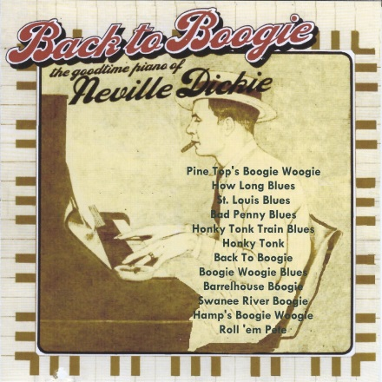

Neville Dickie – Back to Boogie
Notes from the original LP, by Stan Britt
Around about the late 1930’s, the phrase “boogie woogie” became part of the vocabulary of popular music of the period. It was a musical expression that was too last until the present – and one which, undoubtedly, will remain for a long, long time….
It came about largely because of the rather sudden – and, in many ways, quite extraordinary – commercial success achieved by the three black American keyboard artists, Pete Johnson, Albert Ammons and Meade “Lux” Lewis. This talented trio is usually looked upon as being those most closely associated with and responsible for the elevation of boogie woogie on to the sometimes dubious plane of Pop Hit Parade status.
The break-through which Messrs. Johnson, Ammons and Lewis achieved through their powerful, blues-based playing – at various times during their respective careers they were heard alone, together or in a combination of two – spawned a rush of boogie woogie recordings by pianists with, for example, several of the big bands of the Swing Era. Riding on the initial impact of the Big Boogie Trio were the bands of Bob Crosby (whose pianist Bob Zurke achieved personal prominence via recordings like Honk Tonk Train Blues and Yancey Special), Will Bradley (Beat Me Daddy, Eight To The Bar, Rock-A-Bye Boogie, Scrub Me, Mamma, With a Boogie Beat, and numerous others), and Tommy Dorsey (T.D’s Boogie Woogie, an outrageous “pinch” of Clarence “Pine Top” Smith’s Pine Top’s Boogie Woogie, showcasing that band’s pianist, Howard Smith).
Boogie Woogie is a style of piano-playing which makes huge physical demands on its exponents, who require unlimited stamina and strong hand in order to last through a typical evening’s gig. Boogie woogie stems from the Blues and is easily identified by a consistent, repetitive ostinato figure played by the left hand, eight beats to the bar. Its origins were with other pianists, most notably Jimmy Yancey and Pine Top Smith, both of whom combined a basically simple approach, technically speaking, to the blues.

It’s the kind of piano playing which first fascinated a teenager named Neville Dickie, whose playing throughout this interesting set captures the very essence of this infectious type of jazz music.
“Yes”, he told me recently, “I remember those early classic boogie woogie tracks all right – like Meade ‘Lux’s’ original – 20’s Honky Tonk Train Blues, and Earl Hines’ Boogie Woogie On St. Louis Blues which came later, . . . not to mention the many recordings by Lewis, Ammons and Johnson. You can safely say that, in their own ways, they made a distinct impression on me . . .”
That “impression” manifests itself admirably in Neville’s own distinctive treatment of boogie woogie favourites like Barrel House Boogie, Honky Tonk Train Blues, the original Pine Top’s Boogie Woogie and Hamp’s Boogie Woogie (not treated as a two-finger exercise or duet as per its composer, Lionel Hampton!) Pete Johnson’s fine Roll ‘Em Pete – forever associated with marvelous recordings pairing the pianist-composer with blues shouter Joe Turner – receives especially fine treatment from Dickie, whose firm left hand is a joy to hear.
How Long Blues and Swanee River aren’t usually associated with boogie woogie.
Nor, too, is Bill Daggett’s jumping, 1956 R & B hit Honky Tonk. But the transformation to boogie worked by Dickie and his three ever-attentive colleagues – guitarist Brian Daly, bassist Arthur Watts and drummer Ronnie Verrell – is delightful. And Neville’s own Back to Boogie deserves to become staple fare in the repertoire of other boogie woogie practitioners.
Sadly, the art of boogie woogie playing seems to be one that is gradually receding into the past, which is one salient reason for purchasing this album immediately.
Stan Britt

Web Site: www.nevilledickie.com
neville.dickie@blueyonder.co.uk

