Bix Beiderbecke Birthday Bash
Comes To The
Bickford Theatre at the Morris Museum
Mike Davis and the New Wonders Pay Tribute to the Jazz Legend

(Morristown, NJ) – The legendary jazz musician Bix Beiderbecke will be celebrated by cornetist Mike Davis and his all-star group, the New Wonders, with our popular Bix Beiderbecke Birthday Bash on Monday, March 13, at 8:00 p.m. Joining Davis will be Dan Levinson on clarinet, Joe McDonough on trombone, Jared Engel on banjo, Dalton Ridenhour on piano, Jay Rattman on bass saxophone, and Jay Lepley on drums.
Bix was born in Davenport, Iowa, on March 10, 1903 and taught himself to play the cornet largely by ear. He died tragically in 1931 at the age of 28, but during his brief life he became one of the earliest great jazz improvisers along with Louis Armstrong. He is in the Downbeat Jazz Hall of Fame, the International Jazz Hall of Fame, the American Jazz Hall of Fame, the Ertegun Jazz Hall of Fame, and on the ASCAP Jazz Wall of Fame. His records have been inducted into the Grammy Hall of Fame and are in the Library of Congress National Recording Registry.
A graduate of the Manhattan School of Music, Mike Davis is in the vanguard of young musicians bringing traditional jazz to prominence in the New York music scene. The Wall Street Journal called him an “eloquent trumpet prodigy,” and he is much in demand for his ability to capture the sounds of those great musicians of the Jazz Age. His New Wonders Band takes its name from the model of cornet played by Bix and has been called an “unexpected delight” by The New York Times. The band provides a link back to the exciting 1920s when jazz swept a war-weary world.
“All of us in the band have a real passion for the great music from this era,” explains Mike Davis, “and in the Bickford Theatre we have the perfect venue to connect with our audiences. We’ll play both well-known and little-known classics by Bix. And we will be singing some of the tunes he recorded under the name ‘The Chicago Loopers.’ Of course, no Bix tribute would be complete without our rendition of one of his best known recordings ‘Clarinet Marmalade’ which is a New Wonders favorite.”
Tickets for the Bix Beiderbecke Birthday Bash are $17 in advance and $20 at the door and may be purchased online at morrismuseum.org, by phone at (973) 971-3706, or in person at the Bickford Theatre Box Office. The Morris Museum’s Bickford Theatre is located at 6 Normandy Heights Road in Morristown, NJ, and offers free parking and full accessibility. Box office hours for phone sales are Monday through Friday, 10:00 a.m. to 5:00 p.m. Walk-up hours are Tuesday through Friday, 11:00 a.m. to 5:00 p.m.
# # # # #
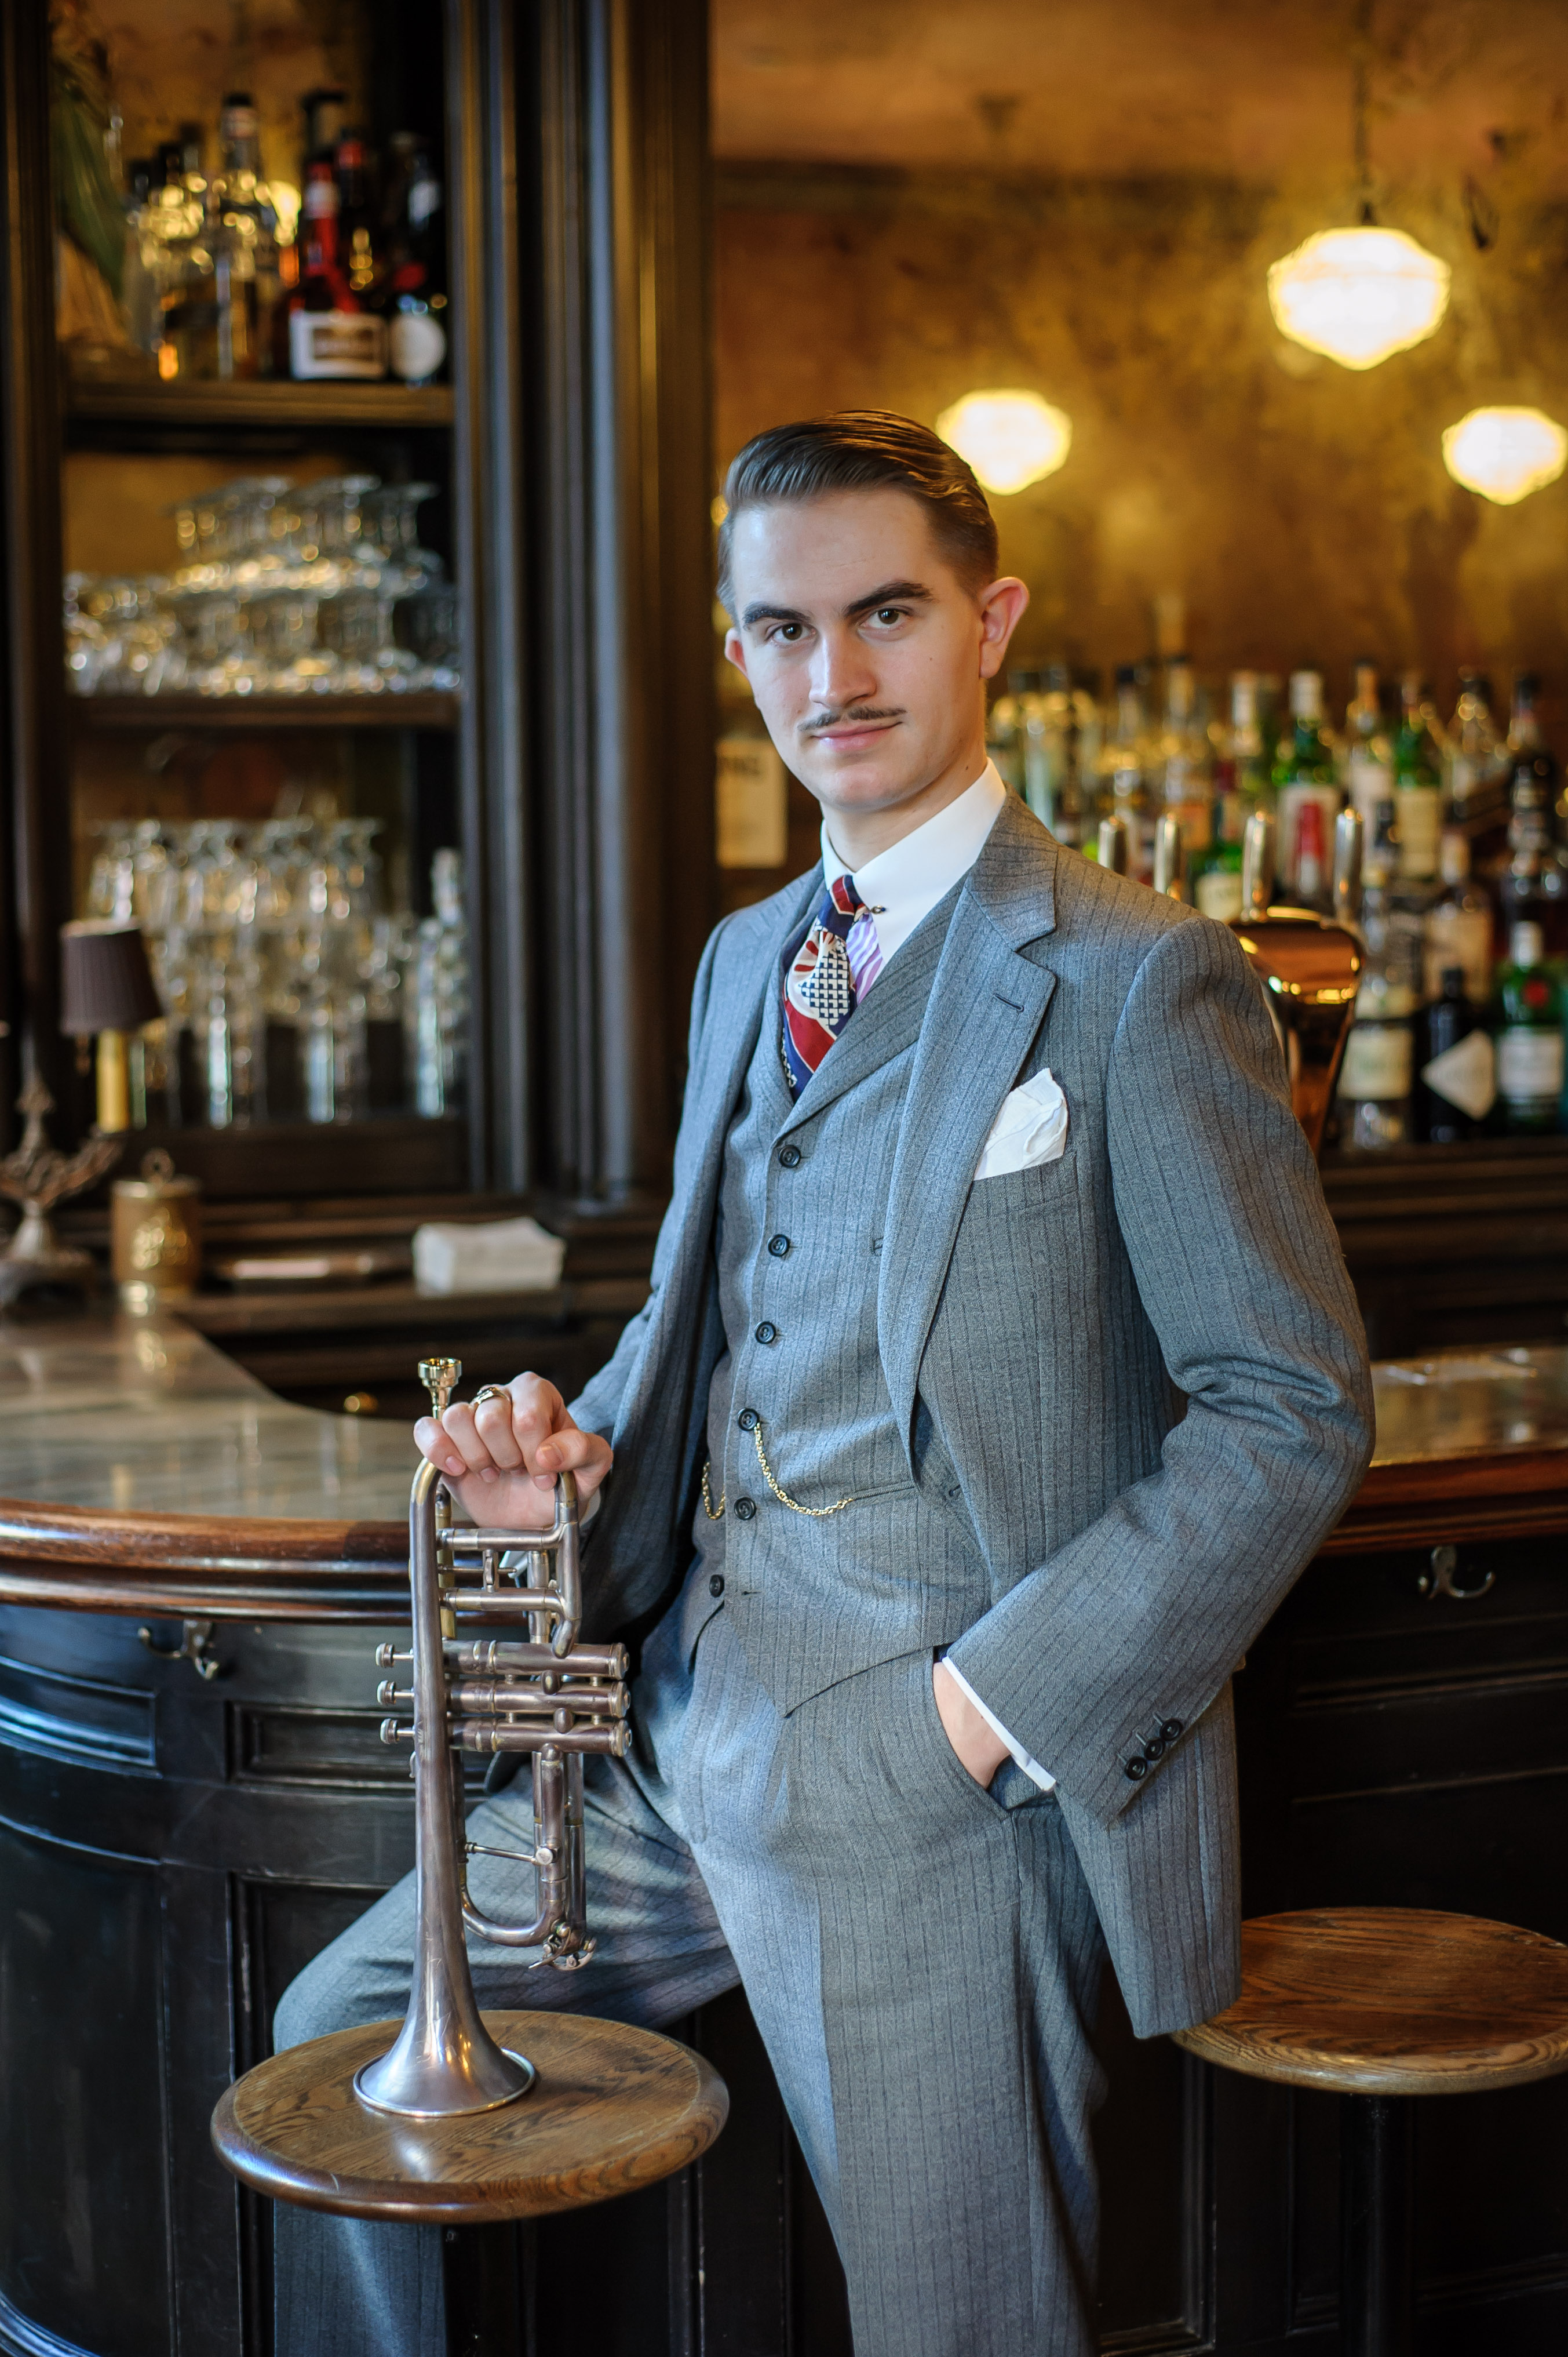
Photo: Cornetist Mike Davis and the New Wonders come to the Bickford Theatre at the Morris Museum for our annual Bix Beiderbecke Birthday Bash on March 13. Photo by Jane Kratochvil.
About the Bickford Theatre
The Bickford Theatre is a professional theater that produces and presents year-round entertainment, including a Main Stage Series, two Children’s Theatre series, a Jazz Showcase Series, and other concerts. The theatre is an Equity Producing Theatre member of the New Jersey Theatre Alliance, a not-for-profit organization of 30 professional theaters throughout the state, and works in conjunction with Actors' Equity Association (AEA) and the Stage Directors and Choreographers Society (SDC). From its beginnings in 1994 to the present, tens of thousands of theater-goers from across the tri-state area have enjoyed the Bickford Theatre’s many entertaining and diversified offerings in theatre, music and dance.
About the Morris Museum
Founded in 1913, the Morris Museum is an award-winning, community-based arts and cultural institution which serves the public through high-caliber exhibitions in the arts, sciences and humanities. The Museum also offers educational programs, family events, and is home to the Bickford Theatre and its wide range of performing arts offerings. Continuously serving the public since 1913, the Morris Museum has been designated a Major Arts Institution and has received the New Jersey State Council on the Arts’ Citation of Excellence, among other awards. The first museum in New Jersey to be accredited, the Morris Museum was re-accredited in 2013 by the American Alliance of Museums.
The Morris Museum is a Blue Star Museum, offering free admission to active duty military personnel and their families, from Memorial Day to Labor Day.
Location and Hours
The Museum is located at 6 Normandy Heights Road (at the corner of Columbia Turnpike) in Morristown, NJ, and is open Tuesday, Wednesday, Thursday, Friday and Saturday, 11:00 a.m. to 5:00 p.m. and Sunday, 12:00 to 5:00 p.m.. In addition, the Museum is open evenings from 5:00 to 8:00 p.m. on the second and third Thursday of the month. Admission to the Museum is $10 for adults and $7 for children, students and senior citizens. Admission is always free for Museum members. For more information, call (973) 971-3700, or visit www.morrismuseum.org.

